Mental health amongst students at the University of Groningen and Hanzehogeschool

Background

COVID19 has impacted student life in universities. In December 2021, a survey was sent out to students across the University of Groningen and Hanzehogeschool to gauge how COVID19 has been impacting their well-being. Both local and international students were invited to participate and provide their input regarding their situation.
Summary

From the survey responses from student in the University of Groningen, it can be understood that students were doing relatively okay prior to the lockdown in December 2021. The lockdown forced students to return back to a more chaotic schedule which impacted their mental health. In addition, student have been more outspoken about going to seek help and provided positive experiences with seeking help. While the difference in responses by Dutch and International students provided similar ranges of response, International students faced greater issues in daily work and sought to obtain help in greater proportions compared to the Dutch students. In general, the support provided by the RUG was not seen as adequate, with International students perceiving the support given less than Dutch students.
The COVID-19 pandemic highlighted deficiencies within the capacity for students to obtain support for their mental health. We are aware that the pandemic is at its closing end now, but this does not mean that the pressure on better mental health will decrease. The urge to better the situation for students still remains a priority, with many students still affected by the pandemic regarding their mental health.

Methods

A Google Form was utilised to generate the survey. Questions were included on the well-being of students (e.g. positivity), academic status, health habits (e.g. drug use, drinking), current issues faced and actions taken to tackle ongoing issues. The survey was sent out to higher education students across Groningen, which included the University of Groningen and Hanzehogeschool. Categorisation between local and international students was determined by the language of response.
A descriptive summary of results were generated and stratified according to language of response and university. Categorical questions were converted to rating scale between 1 to 5 (1 denoting the minimum value and 5 denoting the maximum value). Quantitative measures pertaining to issues were evaluated. Student comments pertaining to mental health were summarised under snowball sampling, with reoccurring themes presented as an overview table.
For this report, only data pertaining to students of the University of Groningen were analysed.
*Disclaimer: Due to the nature of collecting the data and responses, normal distribution was not accounted for all variables. This is considering the variable nature of personal responses pertaining to questions (e.g. changes in study). As such, conclusions derived from these results should keep this point in mind prior.

Table 1: Summary of survey results (n = 481)

 | Total | University of Groningen
 |  | Nederlands | English

Participants | 481 | 381 | 100
1st years (%) | 161 (33.5%) | 127 (33.3%) | 34 (34%)
Obtaining BSA (1 - 5) | 3.45 (1.04) | 3.45 (1.00) | 3.41 (1.33)
Study Success (1 - 10) | 6.51 (2.31) | 6.52 (2.39) | 6.44 (2.33)
Change (1 - 5) | 3.44 (1.04) | 3.44 (1.05) | 3.45 (1.14)
Physical grade | 5.75 (2.04) | 5.80 (1.99) | 5.54 (2.41)
Drinking | 1.63 (1.1) | 1.71 (1.16) | 1.36 (0.79)
Soft drug use (Yes, %) | 158 (32.8%) | 121 (31.8%) | 37 (37%)
Hard drug use (Yes, %) | 94 (19.5%) | 84 (22%) | 10 (10%)
Sleep (1 - 10) | 6.23 (2.09) | 6.33 (2.07) | 5.83 (2.42)
Mental Health (1 - 10) | 5.09 (1.99) | 5.18 (1.98) | 4.73 (2.29)
Positivity (1- 5) | 1.93 (0.88) | 1.98 (0.93) | 1.72 (0.96)
Coursework issues (Yes, %) | 329 (68.4%) | 262 (69%) | 67 (67%)
Daily work issues (Yes, %) | 295 (61.3%) | 226 (59%) | 69 (69%)
Help received (Yes, %) | 237 (49.3%) | 176 (46%) | 61 (61%)
RUG Capacity (Yes, %) | 192 (40%) | 161 (42%) | 31 (31%)

Table: RUG: University of Groningen

Figure 1: How academic success has changed since the academic year started
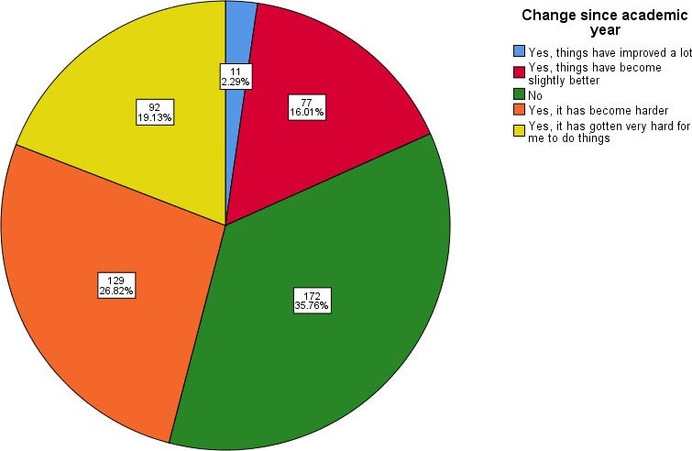

Figure: Breakdown of total student population responding how they gauged changes in their academic success when compared to the beginning of the academic year of 2021/2022

Figure 2: Feeling of positivity per week
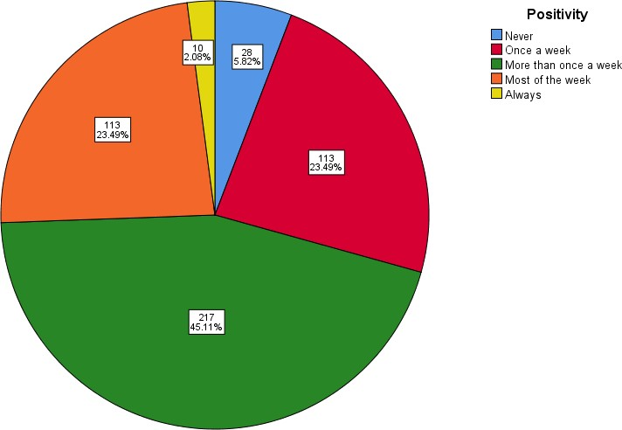

Figure: Breakdown of total student population responding how many times one feels positive over the course of the week

Figure 3: Fitness levels
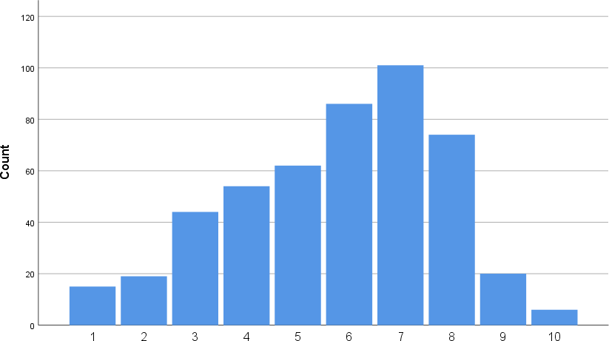

Figure: Bar graph denoting the responses by all students in relation to their perceived fitness level

Results

In total, 481 students from the University of Groningen participated in the survey. 381 students were considered local (e.g. provided answers in Dutch) and 100 students were considered international (e.g. provided responses in English).When comparing to the beginning of the year, 88 students (18.3%) responded that things have become slightly better or improved a lot. Less than half of the students (n = 221, 45.9%) responded that things have become harder since the beginning of the academic year (Figure 1). In comparison, 123 students (25.6%) stated that they felt positive for most of the week or always (Figure 2). No large differences were seen between the Dutch and International students pertaining to academic success and positivity. When considering the level of fitness, students responded with a fitness level higher than average. It should be noted that RUG students responded with a higher level of fitness compared to Hanzehogeschool students.
In general, there were no large differences found between the responses between Dutch and
International students. However, for questions pertaining to ‘Daily work issues’ and ‘Help received’, International students responded at a higher percentage. Thus from the responding International students, they faced greater daily work issues and reached out for obtaining mental help in greater percentages when compared to Dutch students. In addition, the International students responded that they believe in less in the capacity of the RUG to provide mental health assistance.
In the qualitive responses (e.g. comments by students), a recurring theme was found that students found it hard to discuss mental health issues Table 2). This stemmed from responses sharing that it was hard to engage with others regarding one’s mental health and the feeling to not want to be a burden to others. Students who responded reported that motivation was hard to come by and the lack of activity (during lockdown) made it easier to stay thinking about negative thoughts. Responses by International students highlighted that studying abroad was and has been a great experience.
However, the limitations that have been imposed (e.g. lockdown, travel restrictions) have limited the experiences during the period of their study.

Table 2 Comments by Dutch and International students pertaining to their experiences with mental health (Dutch responses were translated to English) (n = 160 comments)

Talking about my mental health is difficult not by choice by rather as I do not know how to engage
with others with my situation. I do not want to be a burden to others.
I am not enjoying life and having issues with motivation. It has become harder to start working on
tasks (academic and in general) and study delay is becoming an issue.
The lack of activity made it easier to linger on negative thoughts and is mentally draining.
Concentration on tasks is difficult.
Moving to a new country has been a great experience but the limitations imposed have limited
my experiences throughout my studies
To tackle mental health issues faced (over the COVID19 period), I have begun seeing a therapist –
it has been very helpful for being able process the situation and understand my condition (e.g. depression)
(With the lockdown restrictions reintroduced in December 2021) I was able to be back on track
with my life but re-entering lockdown pushed me back to struggling to find balance
In general, things are going poorly (mental health, academics, social life) (range from beginning of
COVID19 to recent academic year). Engaging with physical activity has helped but being lockdown has not helped

Tips and advice:

In the next academic year, Brightspace will be introduced at the Rijksuniversiteit Groningen, this will be a great opportunity for the UG to create and guarantee enhanced visibility and accessibility regarding mental health resources for students. It is important that a maximal amount of visibility is reached to create a ‘safe space’ within the RUG for students, where they feel like that there is help available for them to make use of.
Concerning the quality of the mental help that is offered as of now, we have seen complications with the quality of the help that students get. Scenarios where students are put into so-called ‘group conversations’ or ‘speed-sessions’ where a student has to portray their worries in under 10 minutes. These scenarios have a detrimental effect on the way that students experience the help that is offered, resulting in a domino-effect of them not asking for help anymore or any longer. Through mouth-to-mouth conversations, we see that this sentiment of disappointment is spreading in the social circles that students find themselves in.
This lack of personnel and understaffing within the Student Service Centre directly leads to insufficient results. We therefore urge the UG to hire more student psychologists with proper training to handle emergency situations and act accordingly. In the current system the average waiting time is one month, which is far from helpful and desirable for a possible psychological complaint.
Then, to enhance the visibility of the various resources that the UG offers for different complaints (think about harassment, bullying, personal problems, problems concerning studies, etc.) we would advice to invest in a flowchart that is accessible and easy to find in Brightspace. A flowchart will

decrease the distance between students and the resources that are available. An example can be found in appendix 3.
The initiative of creating a student health ambassador’s (SHA’s) committee should be centrally supported and implemented during the upcoming academic year. This will be by student volunteers, for students at the UG. Examples of this programme would entail finding the SHA’s at university buildings and conducting them directly about problems that they are facing at the moment concerning mental health. Their role would be to redirect the students to the appropriate direction of the resources that they in need of. Furthermore they can provide useful information for international students regarding the Dutch healthcare system (think of; how to get a GP, how to get a letter of referral, etc.)
Accomplishing these goals

We understand that urging the UG for better help regarding mental health is not something that can be done overnight. This is why we would encourage the UG to get in contact with student representative bodies, this can be the University Council or the Groninger Studentenbond, both of which have first-hand experiences with the mental health resources that the UG has to offer. In conducting this research we hope to have shown that we can function as a bridge between the UG and its students, offering advice and gaining intel about the situation.
Points to consider:

As there was no previous survey conducted on the students, denoting how COVID19 has changed lifestyle habits over a longer study period (e.g. to pre-COVID19 times) cannot be gauged. In addition, the year of study information was only collected for 1st year students therefore impact on how it affects students across different years cannot be gauged.

For any questions regarding the analysis of the survey results, please contact: contact@doughnutparty.nl

Appendix 1: Soft/hard drug use
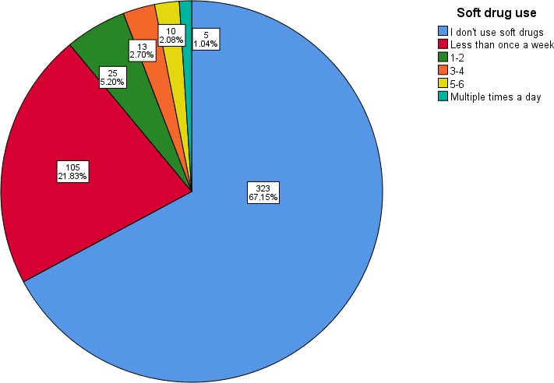

Figure: Breakdown of total student population responding their current soft drug use

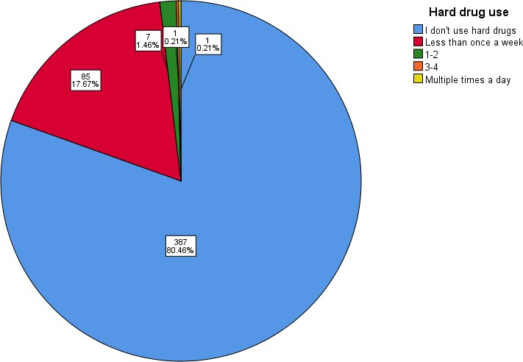

Figure: Breakdown of total student population responding their current hard drug use

Appendix 2: Drinking habits

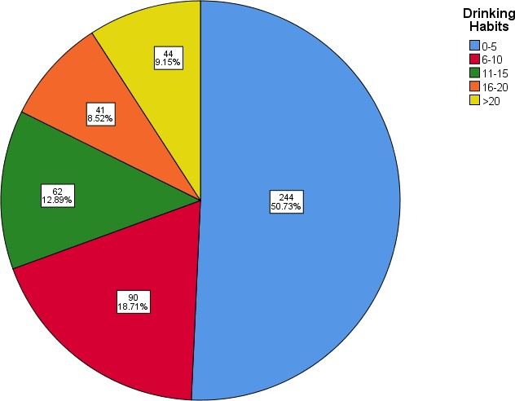

Figure: Breakdown of total student population responding their current drinking habits

Appendix 1: Reporting unacceptable behaviour in the UMCG

